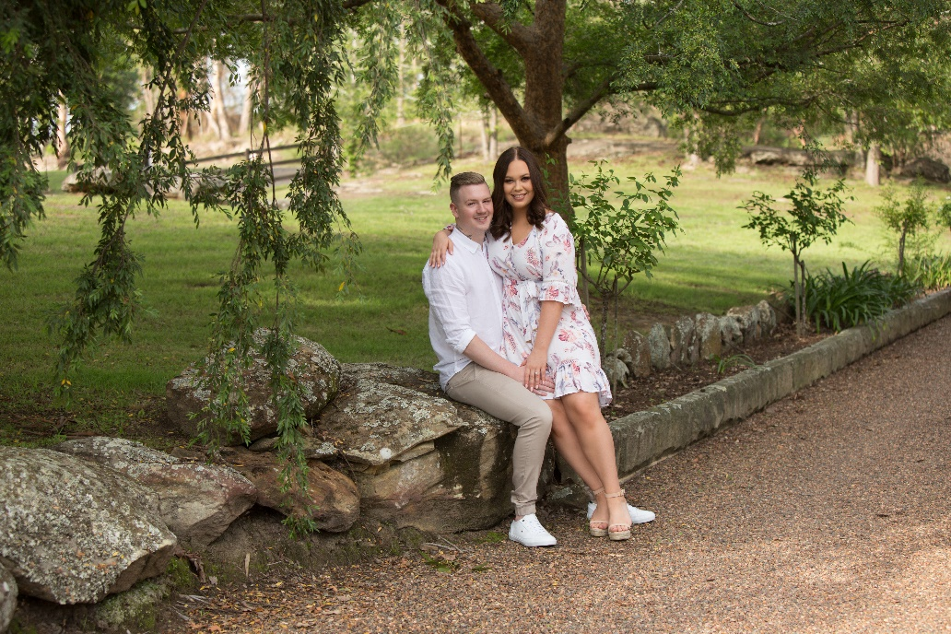
Change of Plans
Due to unforeseen circumstances, WE REGRET
TO SHARE WITH YOU THAT THE WEDDING OF

MEGAN & STEPHEN

HAS BEEN POSTPONed
A date will be advised in the near future.

